* logistic regression
  + classification, loss function and compare with linear regression

classification:

loss function:

compare with linear regression: returns the probability a class gets

* + 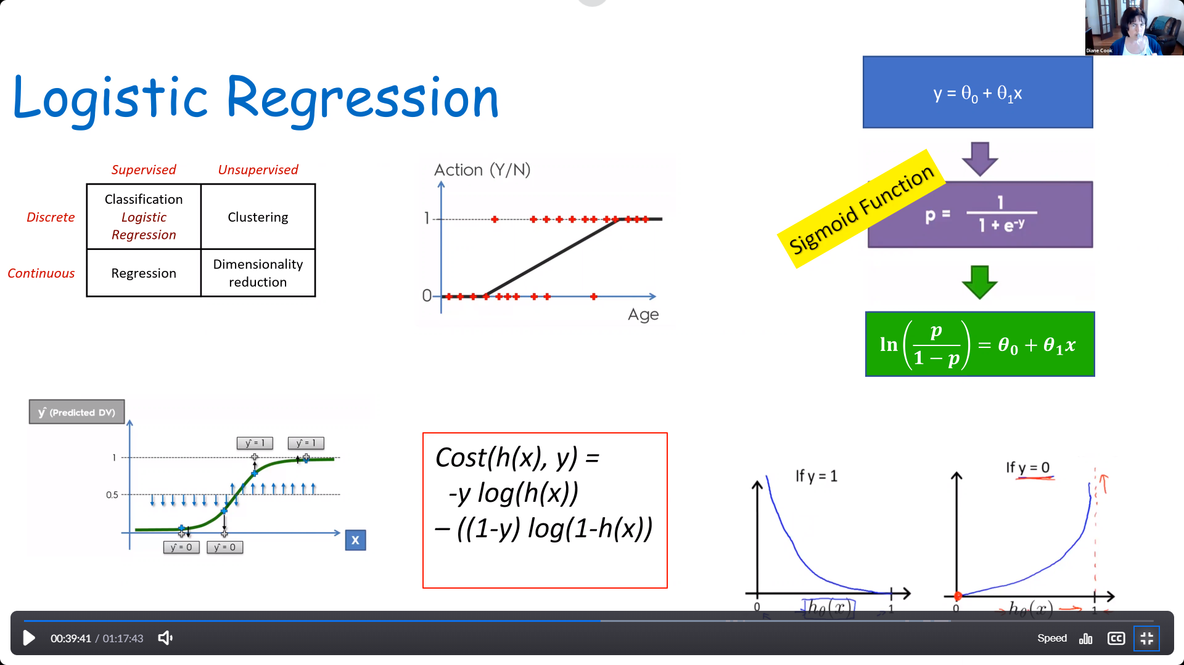
* multi-layer neural networks
  + tanh activation function and motivation

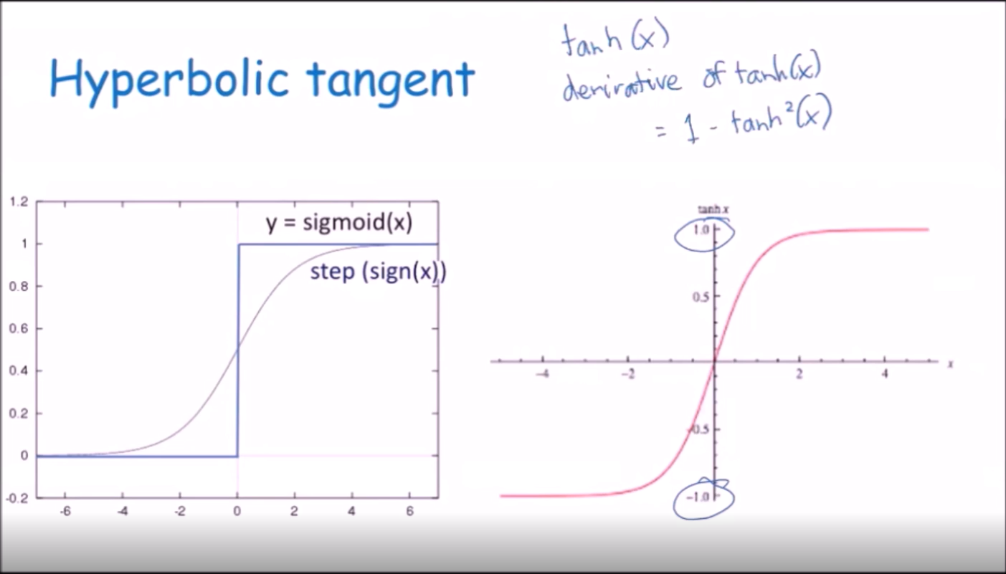

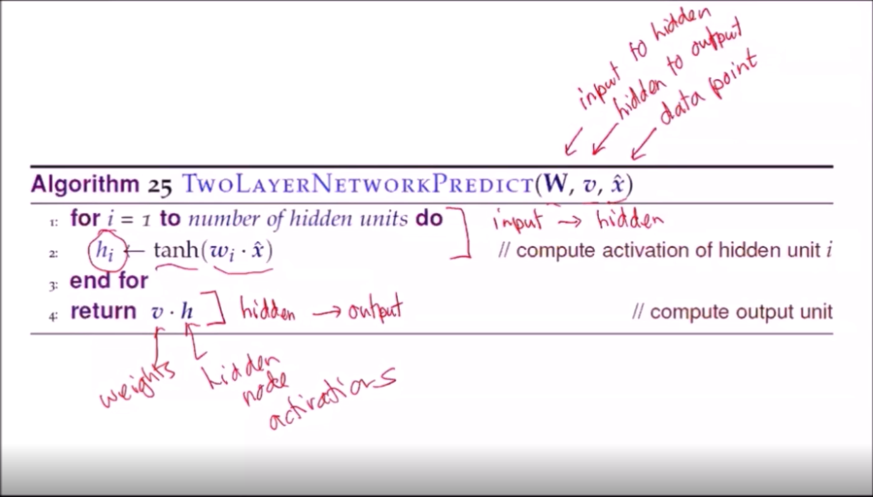

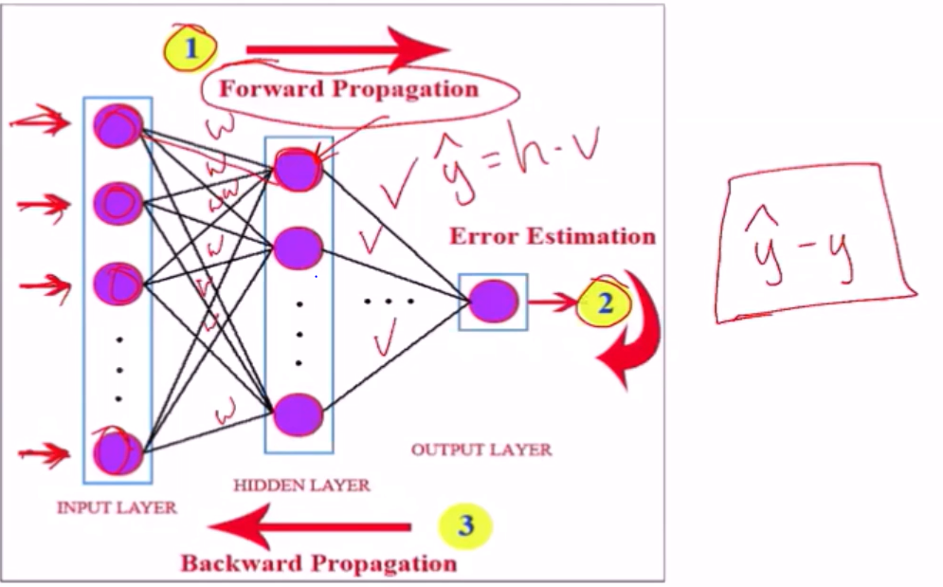

* + forward propagation to compute output
  + backward propagation to compute weights

code and method of how to calculate forward and backward propagation

forward propagate:

1. calculate activation of ai=sum(wi\*x)
2. compute activation of hidden node hi=tanh(ai)
3. compute output output=sum(v\*h)
4. calculate error er=expected -output
5. calculate gradient output=(previous v)-er(hi)

backward propagate:

1)calculate new weight for output layer: previous weight += er\*wp(1-tanh^2(ai)x

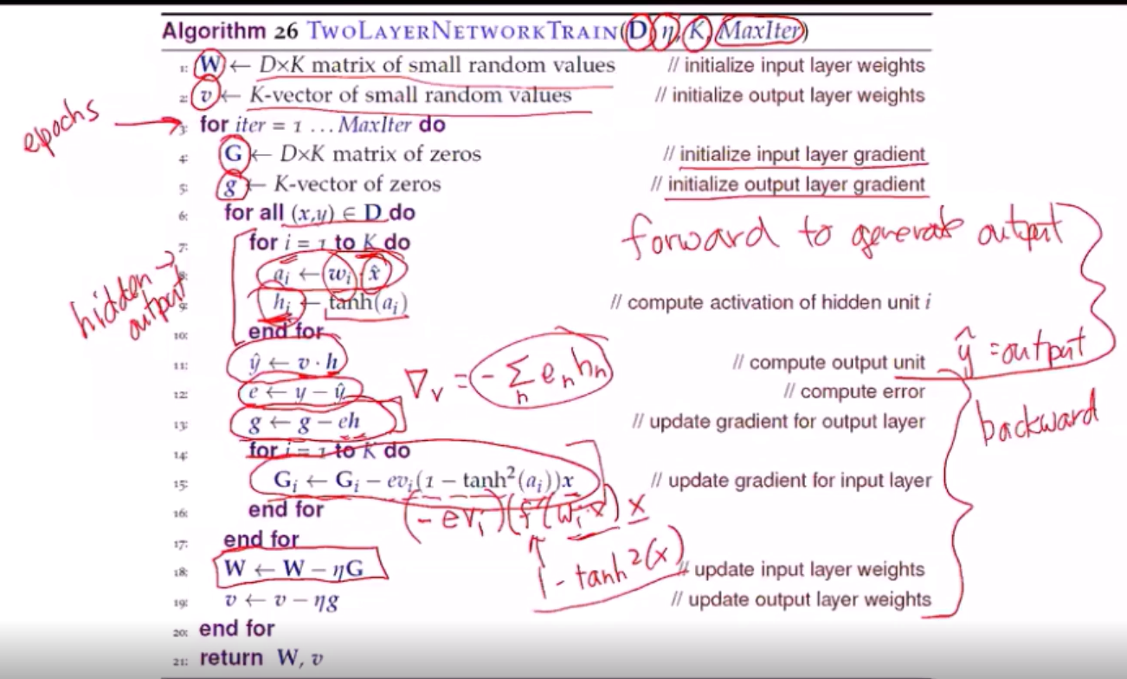

* + inductive bias:

prefers sparse weight vectors

smooth interpolation

* + hyperparameters and impact on underfitting, overfitting

hyperparameters are like the variables in a network, right. These are the hidden units and learning rate. Just like in previous sections, if you have too many, you risk overfitting. Too few, and you risk underfitting. At least that's how I've been thinking about it.

And regularization helps prevent overfitting when there are many hyperparameters.

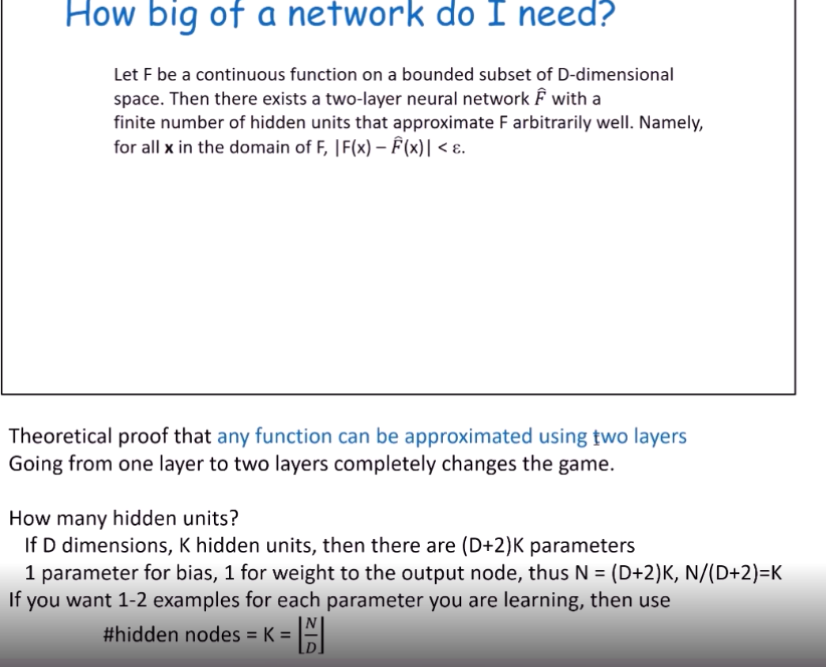

* deep networks, convolutional neural networks
  + convolution, convolutional neural network, softMax, pooling, ReLU, RNN
  + convolution layer
  + 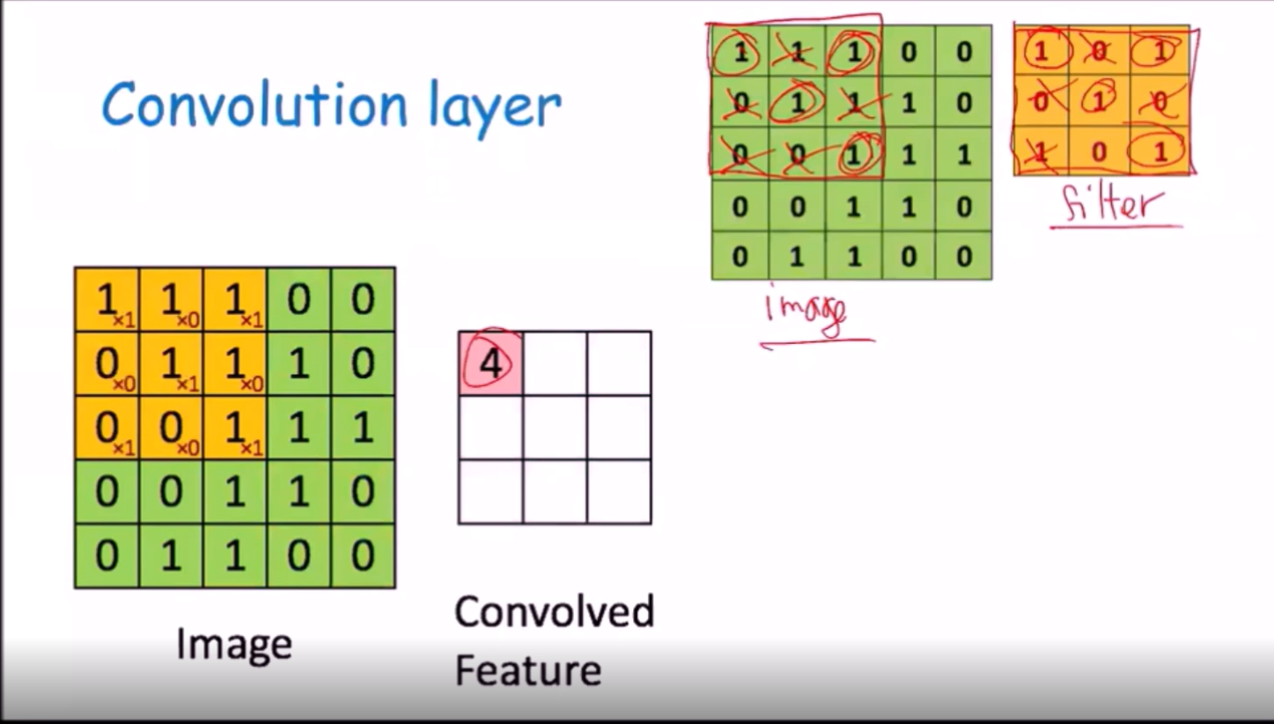

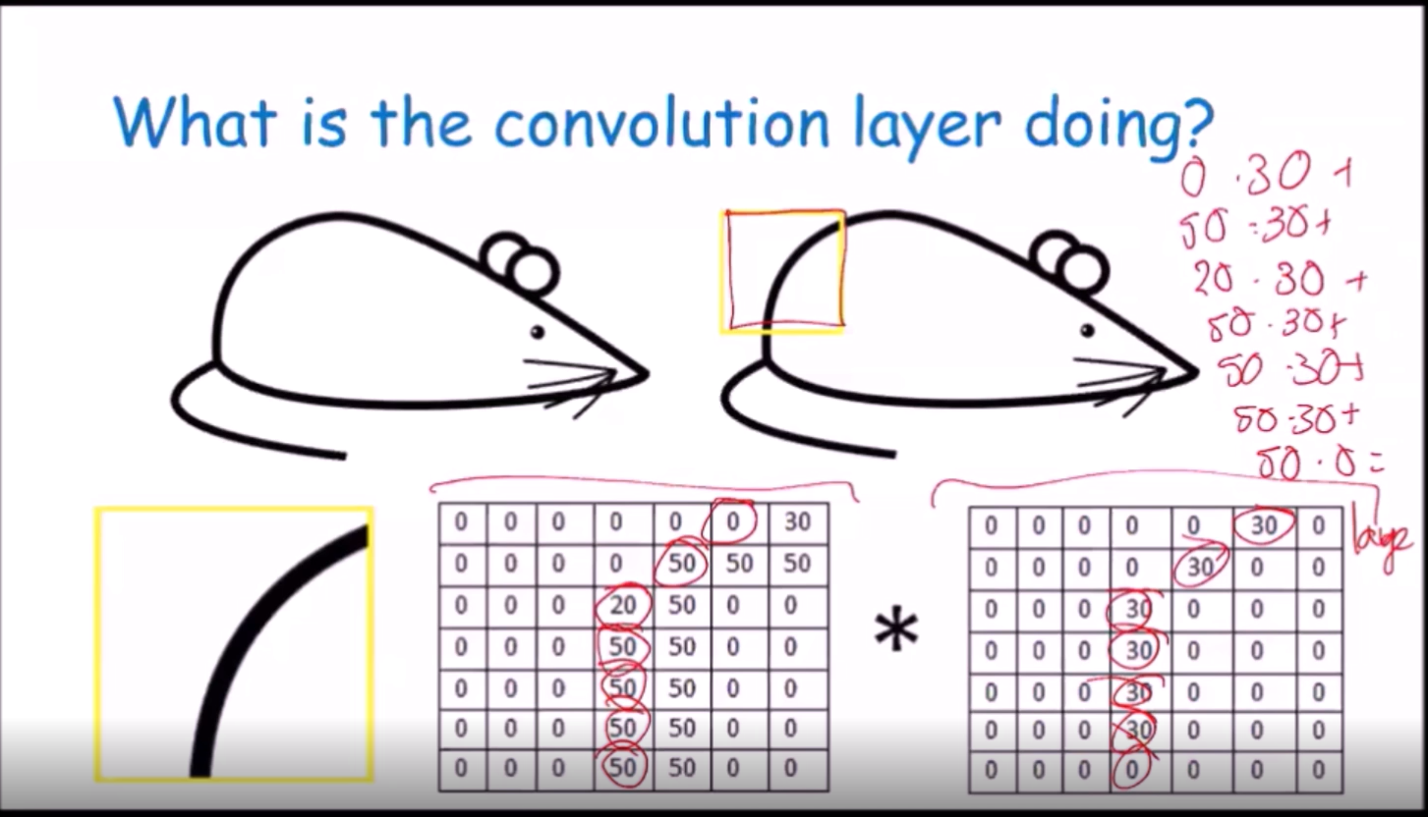

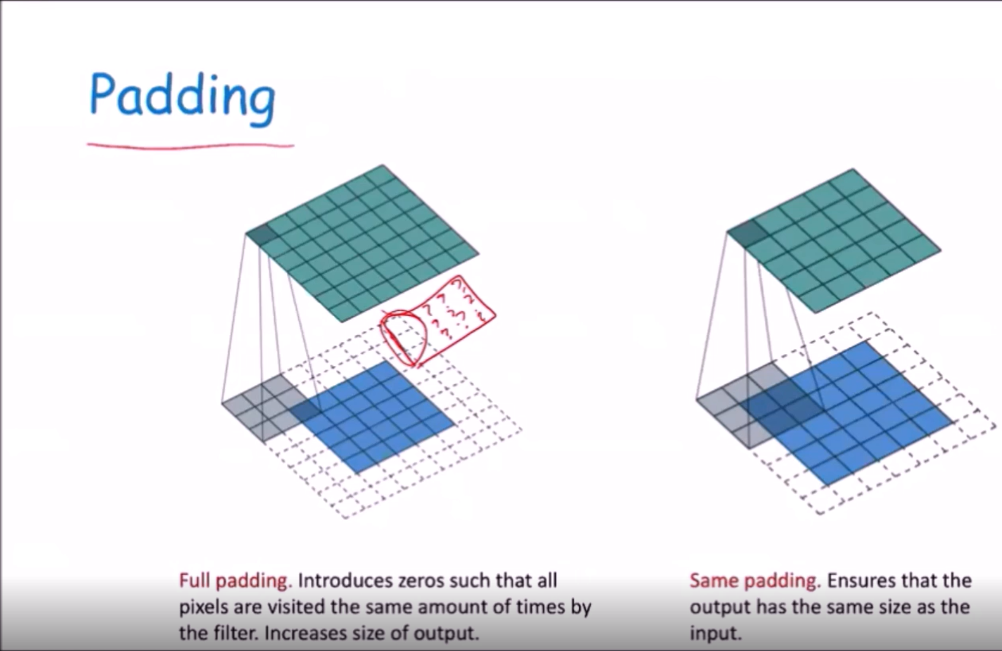

Pooling:

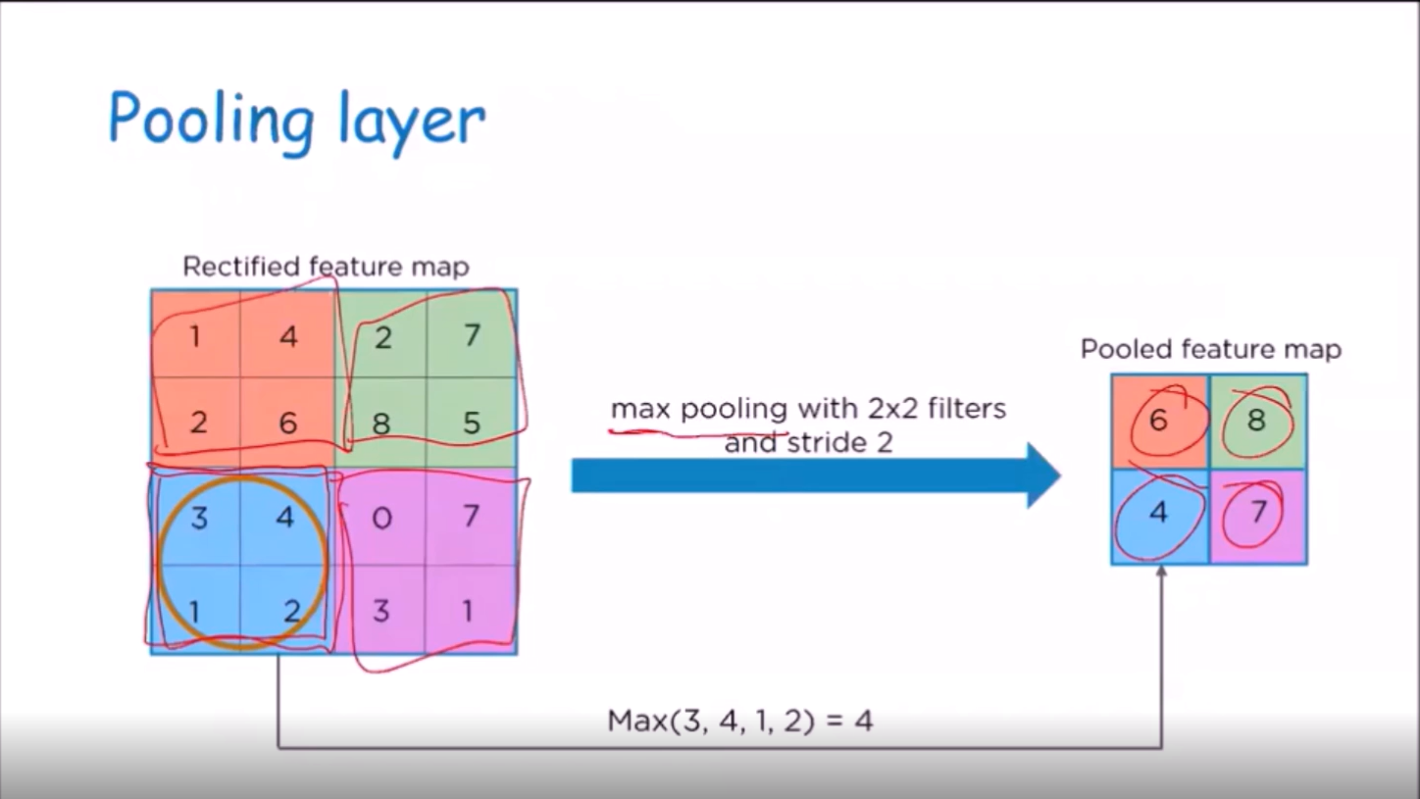

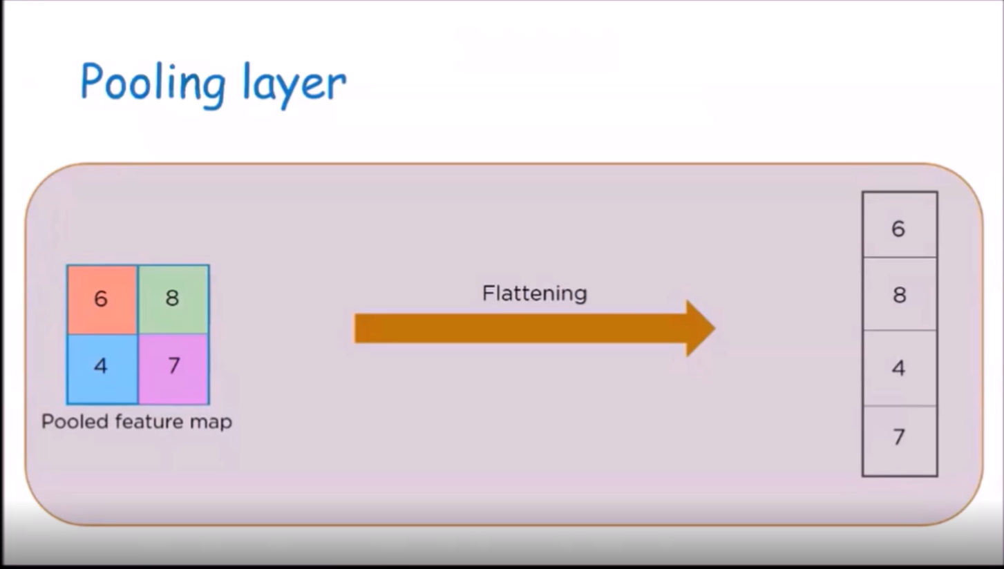

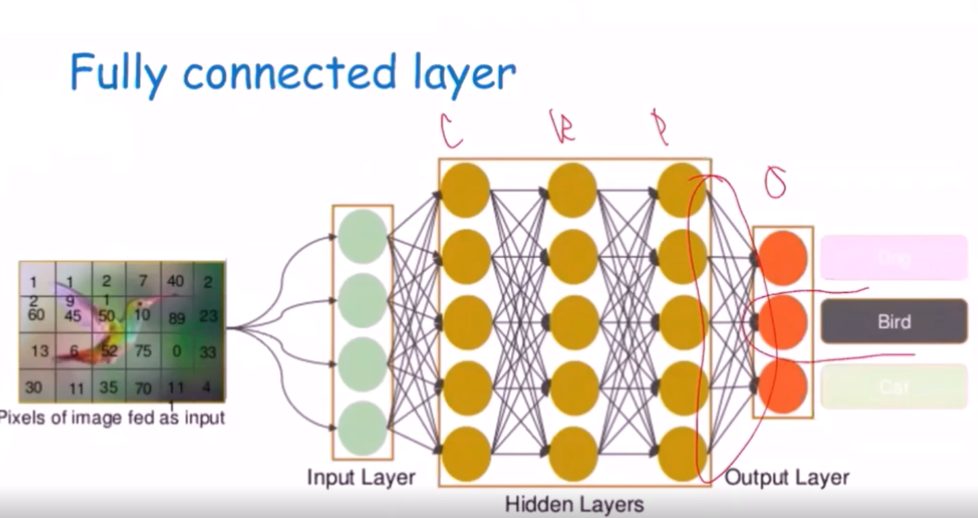

Returns output with the highest value to determine type of image.

reLu:an operation that is applied to all the element with in the image 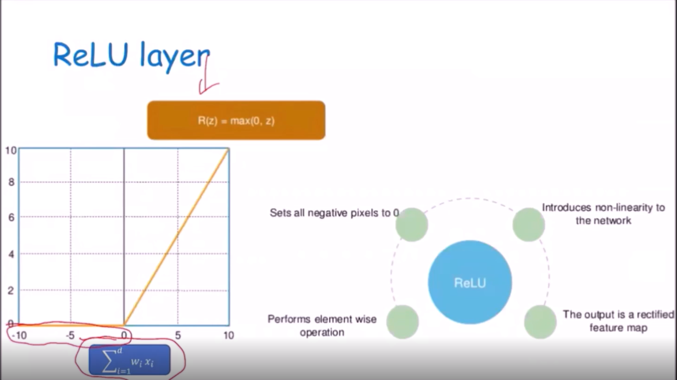 makes nonlinear images, with non linear feature includes transition between pixels, border etc. replace negative values to 0

soft max: A neural network with one output node is typically used for regression, you are mapping features of input data onto a continuous value output. How then do we use a neural network for multi class classification? In this case what is often done is to create multiple output notes, one for each possible class value. Each output node and the weights of the edges pointing to those output nodes are trained individually. When we use the network for classification, the numeric values generated from each output node are converted to a probability distribution and the highest-probability label is output. That last step, converting the values to probability distribution and our putting the max label, is a softmax function.

Return the feature with the Maximum activation

RNN: used for learning sequences

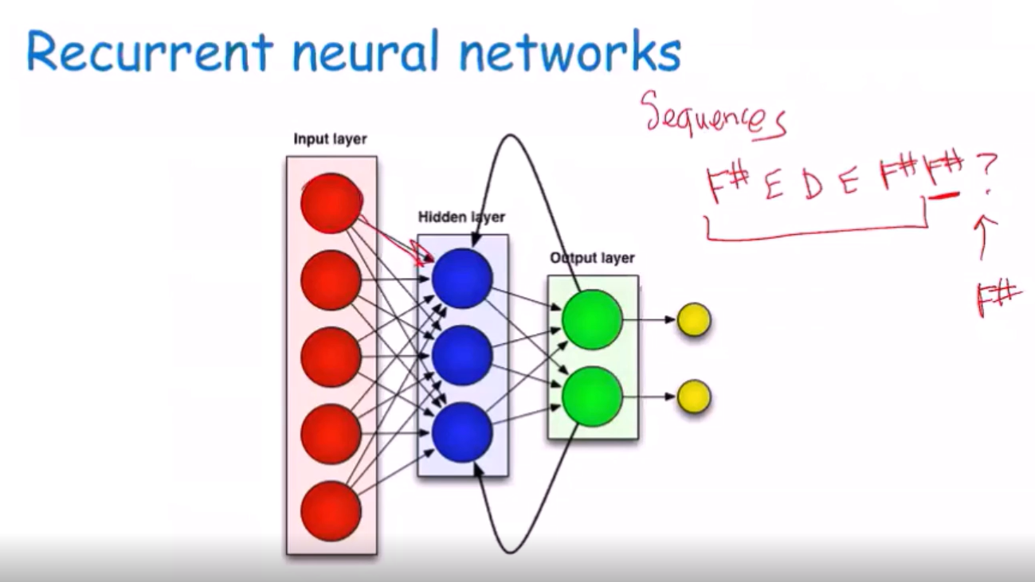

* support vector machines
  + constrained optimization, hard margin, soft margin

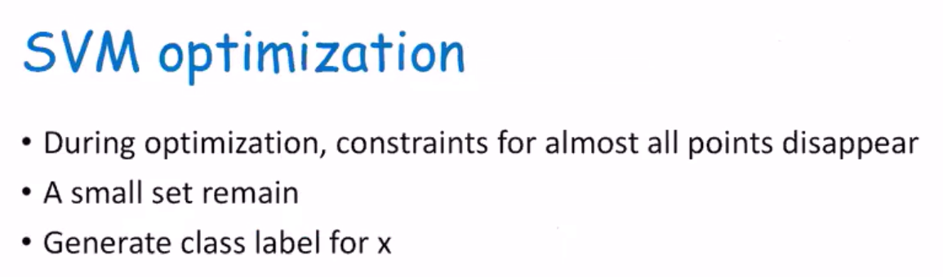

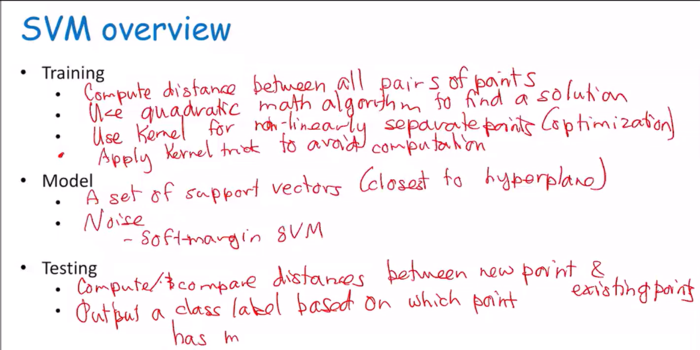

constrained optimization:

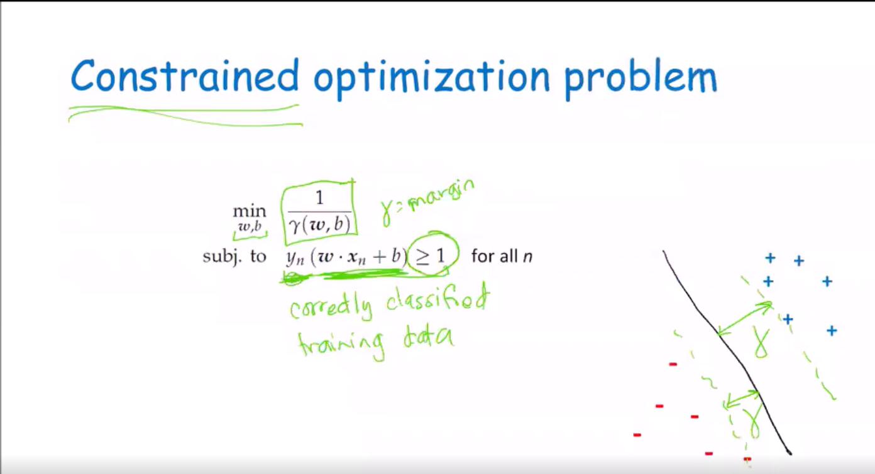

Hard margin: enforces that constraint so all the data is classified correctly

Soft margin: penalizing the formula for using the slack

* + role of hyperparameter in overfitting and underfitting

if the value of C in the slack is small leads to overfitting, if value of C is large than lead to underfitting.

* + slack parameters, size of the margin, kernels

slack parameters: value to move incorrectly classified

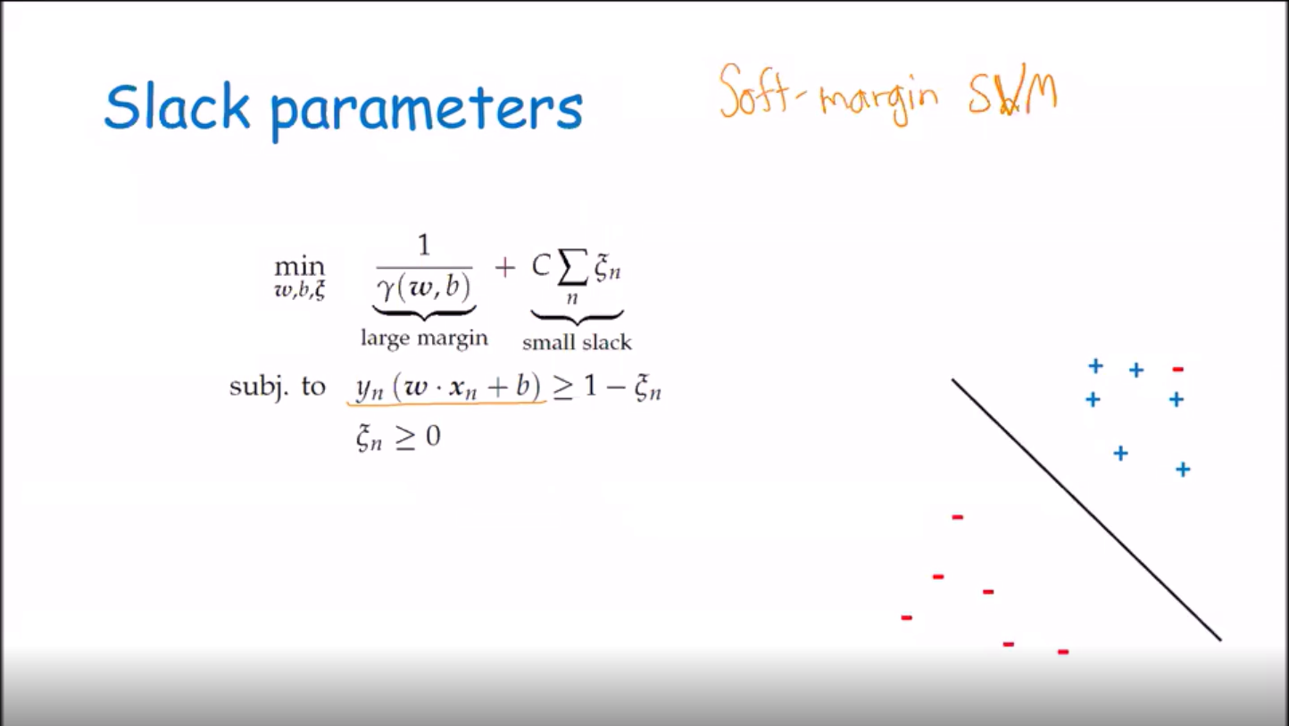

Size of the margin:

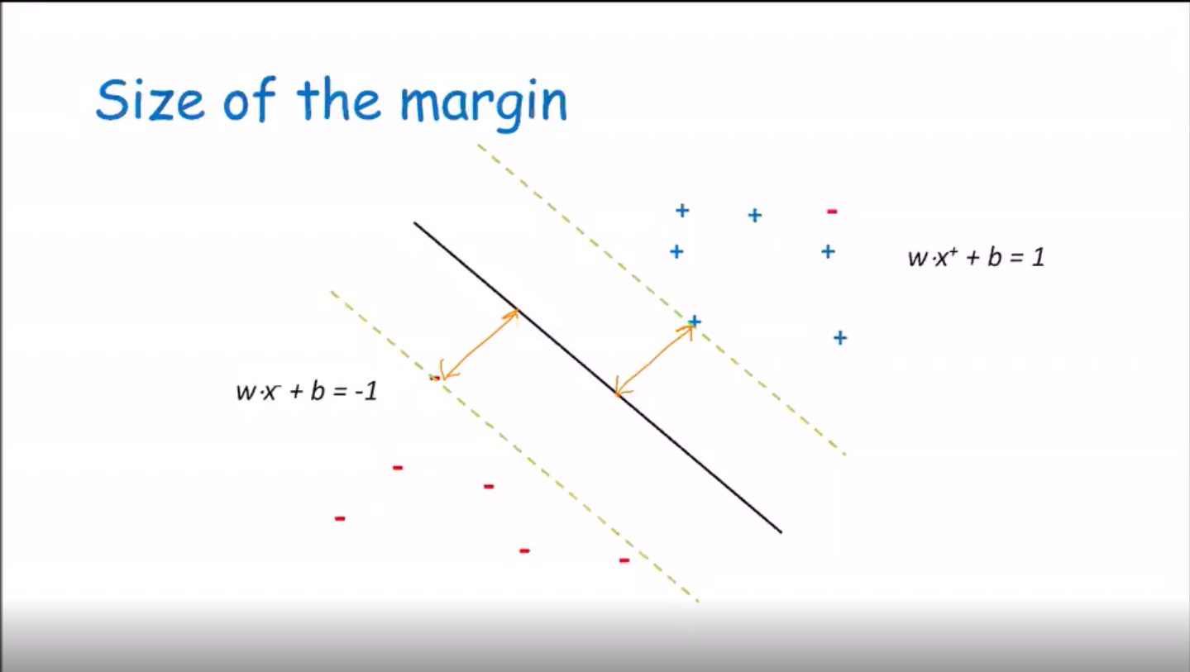

Large margin->easy

Small margin->hard

Too converge on decision boundary

Maximize gamma to give best generalization

Margin is always positive because the product is always positive

Kernels: add kernels to increase dimension to minimize computation.

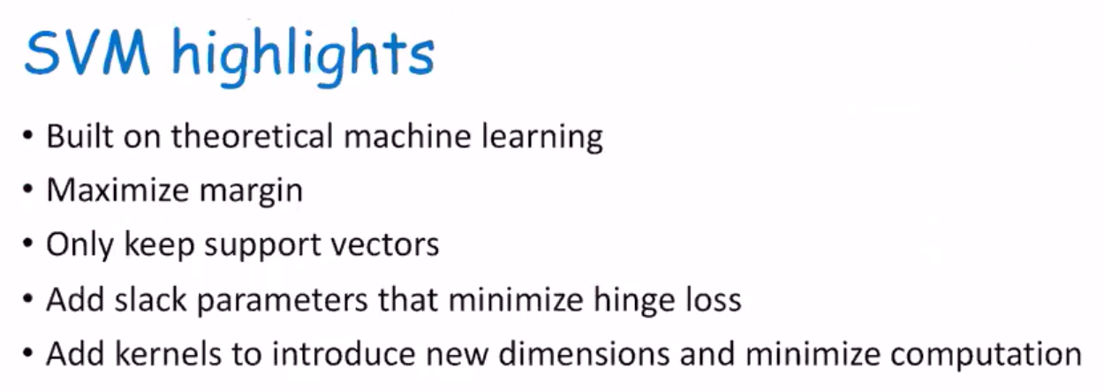

* ensemble classifiers
  + voting, resampling, bagging, boosting, AdaBoost, random forest

voting: 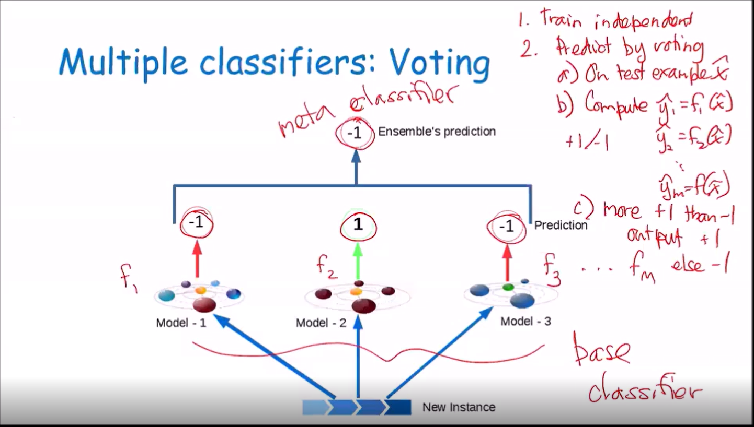

resampling: This is a technique from the statistics literature based on the following observation. The data set we are given, D, is a sample drawn i.i.d. from an unknown distribution D. If we draw a new data set D˜ by random sampling from D with replacement1 , then D˜ is also a sample from D.

bagging: Applying this idea to ensemble methods yields a technique known as bagging. You start with a single data set D that contains N training examples. From this single data set, you create M-many “bootstrapped training sets” D˜ 1, . . . D˜ M. Each of these bootstrapped sets also contains N training examples, drawn randomly from D with replacement. You can then train a decision tree (or other model) seperately on each of these data sets to obtain classifiers f1, . . . , fM.

Boosting: 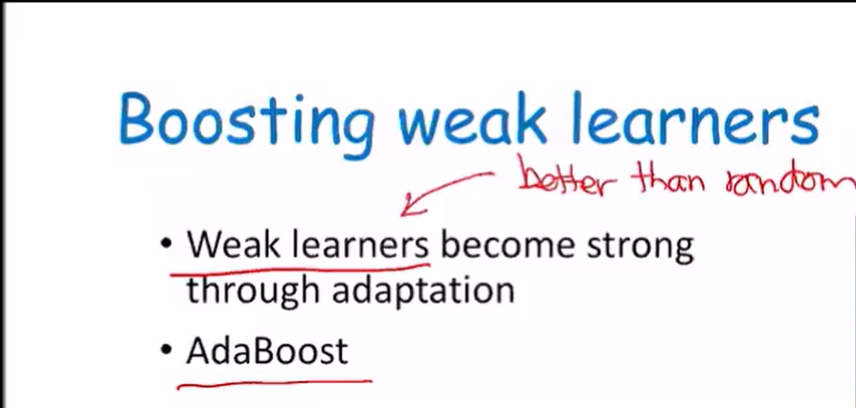

Adaboost: 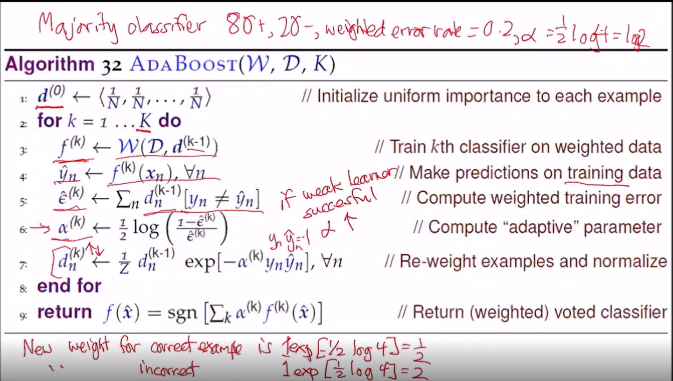

Reduce weight for date that was classified correctly and increase weight on data classified incorrectly

Random forests: 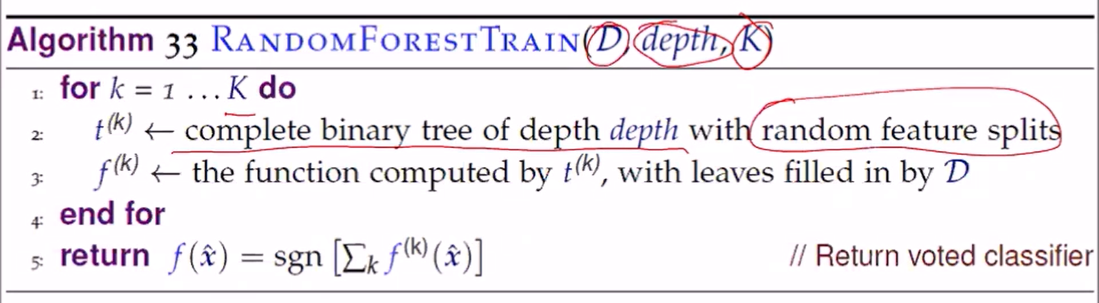

Avoid overfit, very fast to train

* + ways to establish diversity

classifiers, hyperparameter, dataset

* k means++
  + cluster initiation, furthest first, probabilistic selection of cluster means

k means ++

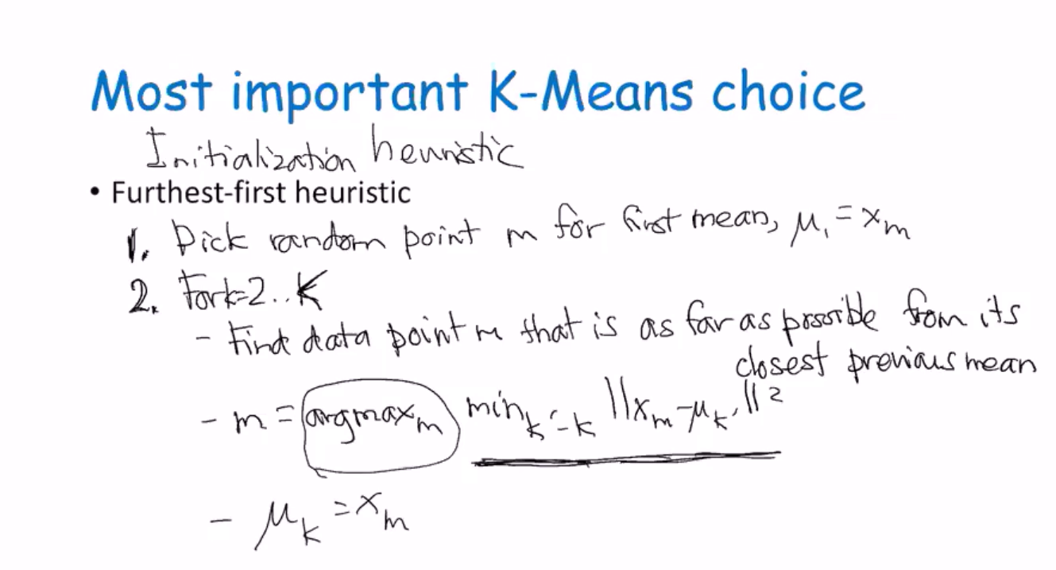

Furthest first:randomly chooses the first point and select the next point to be the point furthest point from the first point, the next selected point will be a point furthest away from both.

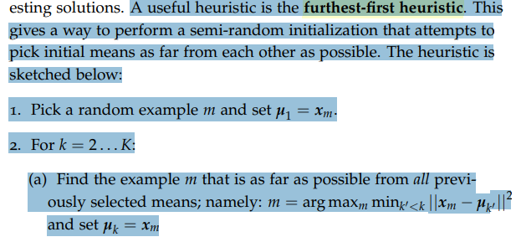

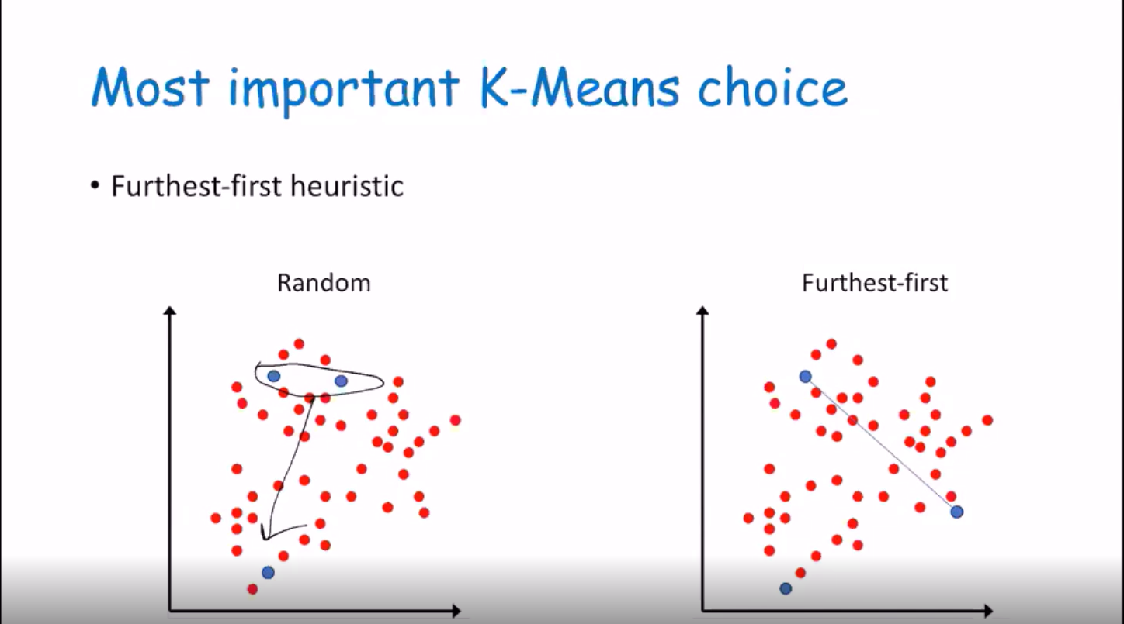

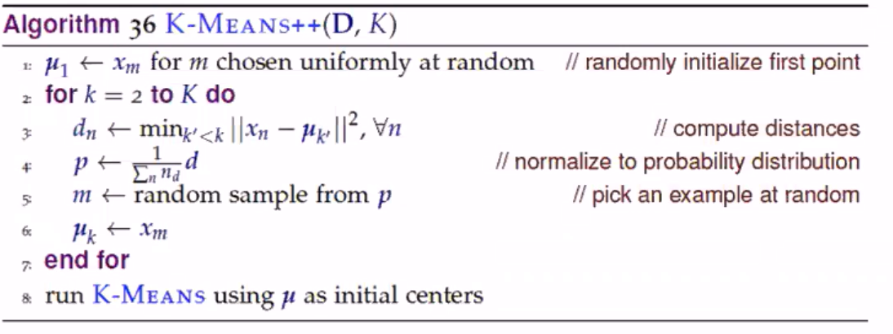

* dimensionality reduction
  + principal component analysis, principal components

principal component analysis:

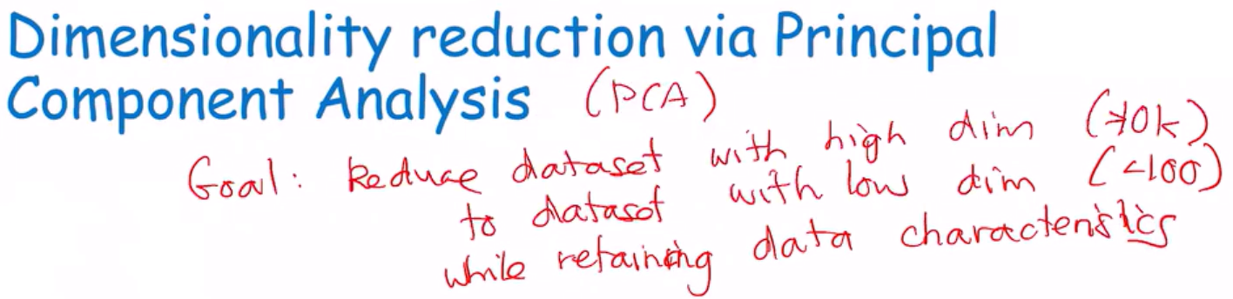

* + minimize data distance to line

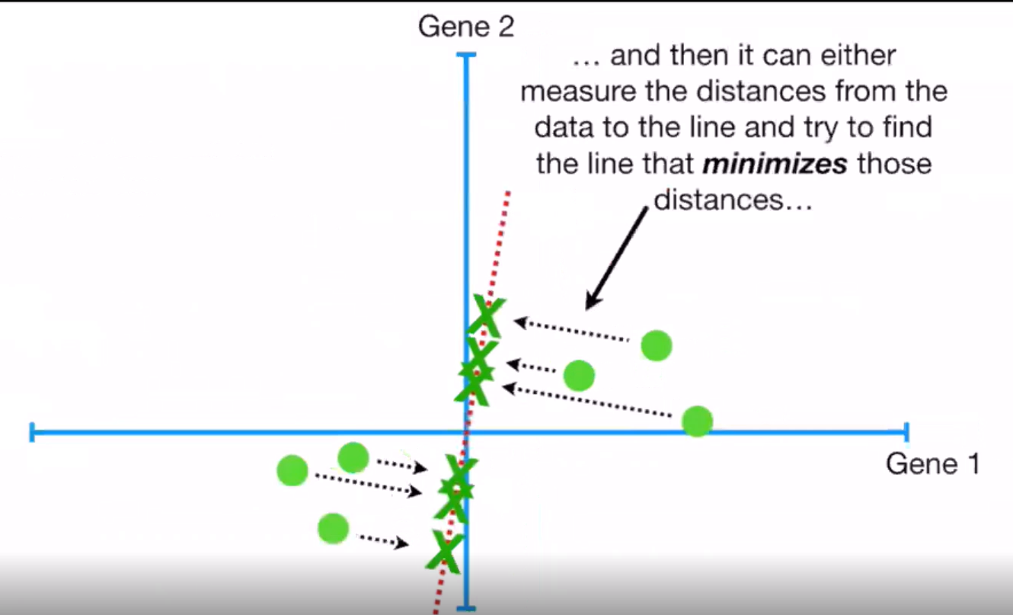

* + maximize distance of projected points to origin
  + 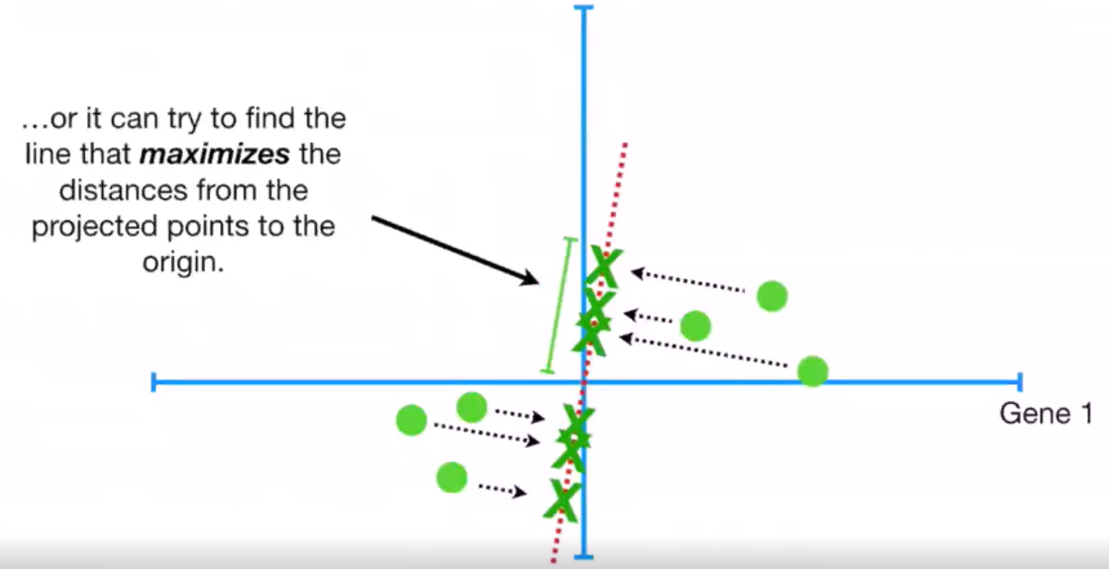

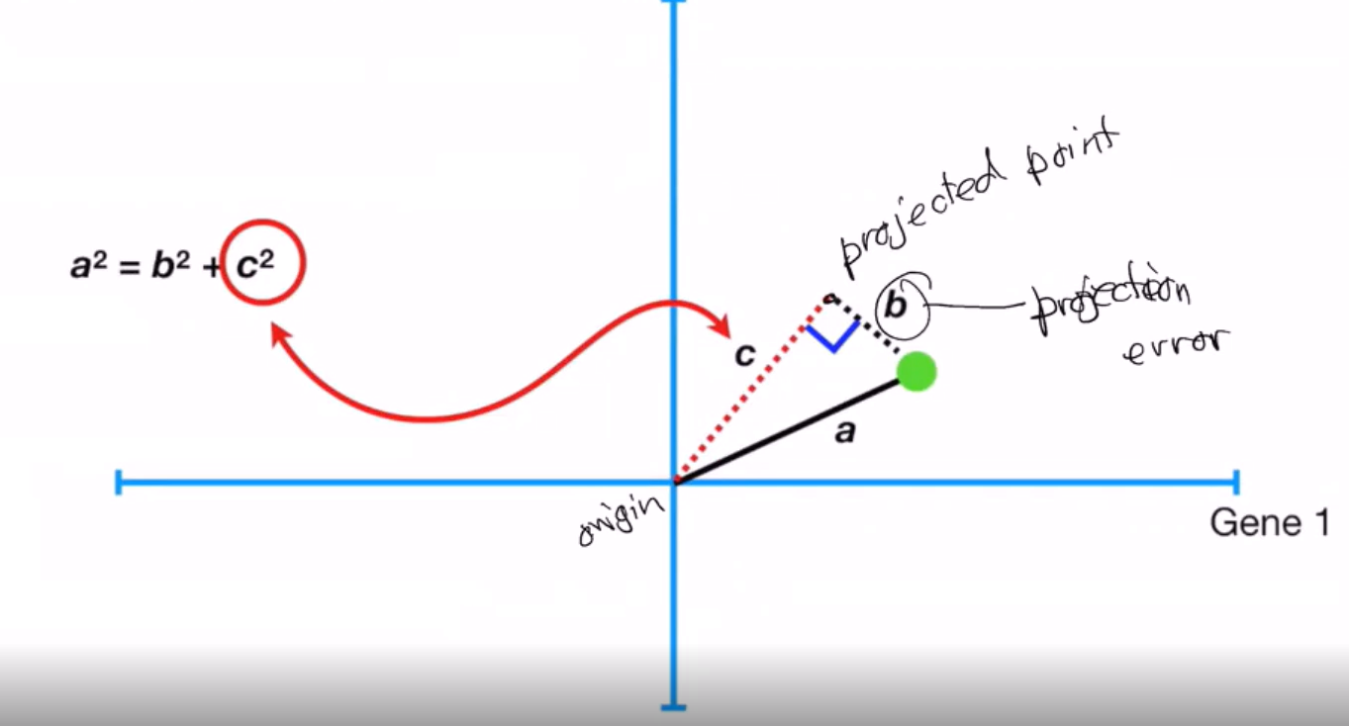

* + selecting components

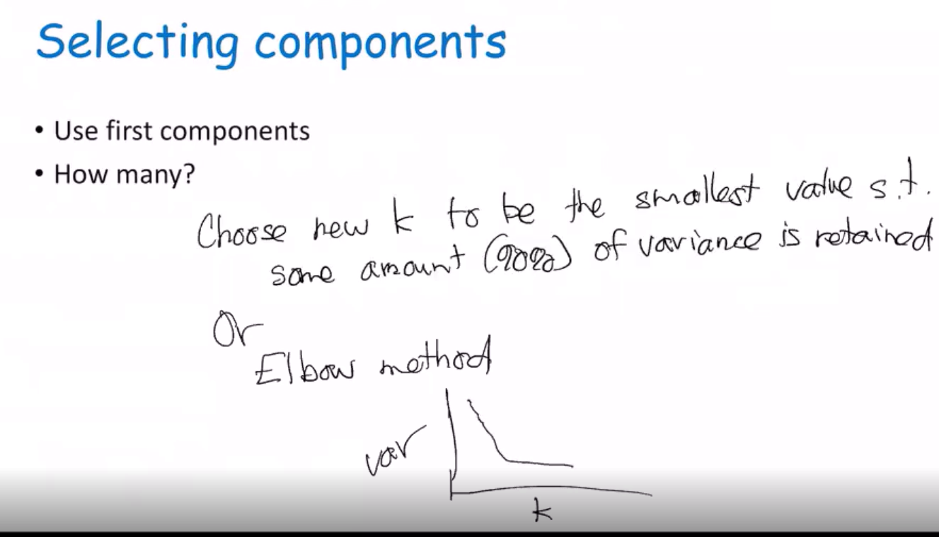

* + visualization of first component, additional components

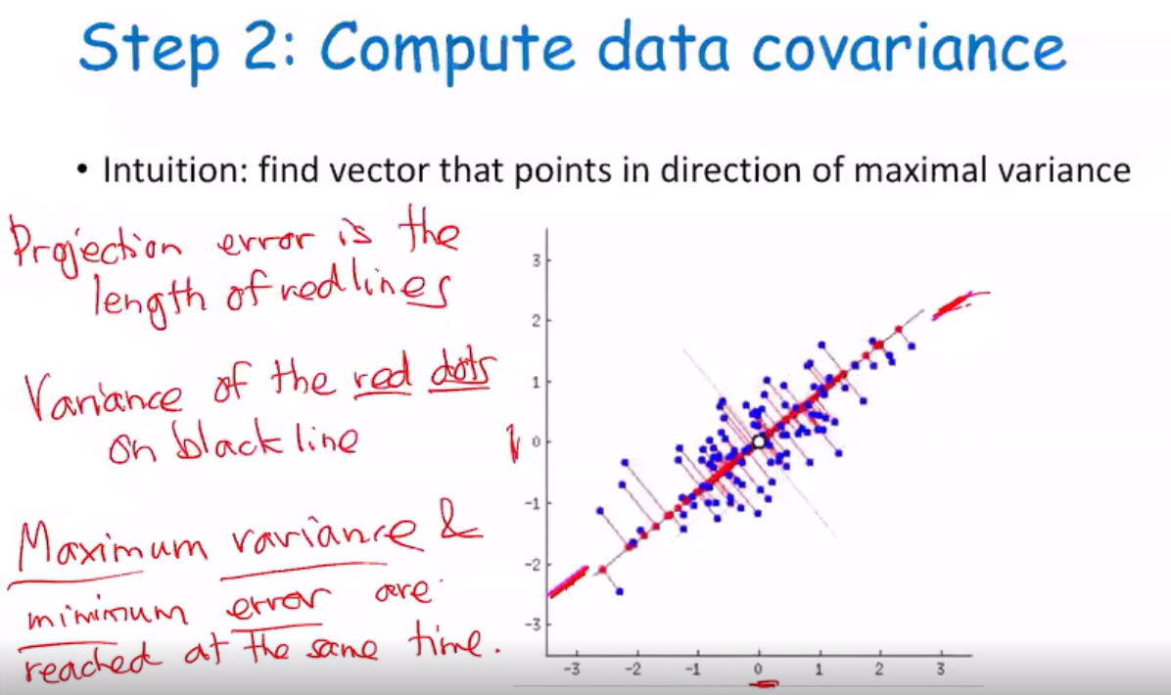

* overall
  + remember highlights of algorithms discussed throughout semester
  + be prepared to compare and contrast methods

pseudo code

